**UWF Cyber Club *11 September 2018* Meeting Agenda**

Attending Officers: ***President, Vice President, Treasurer, Web Master, Secretary***  
Attending Members: ***cc214, emm59, cck12, tjb50, tbw14, dr40, iwb1, clj53, jgf8 dtr9, jdh97, jmc163, Nico, twc8, jmf66, jtc38, Bm80, mam181, angeltcamacho, mem89, cb113, Jt85, Ayr7, jmy13, liamzilla4777, chu1, jmm166, erv3, sb166***

1. Kahoot Quiz – ***Fall Semester Intro Survey***
   1. 1st Place winner – ***cc214***
   2. 2nd place winner – ***emm59***
   3. 3rd Place winner – ***cck12***
2. Presentation – ***General Introduction to the Club***
   1. Introduced the officers
   2. Introduced the members
   3. Introduced the club
      1. We are a special interest club.
      2. We try to create a learning environment without it being like a class.
      3. We are always open to advice and content from our members.
      4. Our members are our biggest resources.
   4. Talked Competitions
      1. ***MITRE***
      2. ***SECCDC***
      3. ***FC2 - Upcoming***
      4. ***Cyberthon***
      5. ***Itenwired - Upcoming***
   5. Talked about club resources
      1. ***Presenters*** 
         1. ***Harry Huelsback***
         2. ***David Taylor***
         3. ***Jimmy Wiley***
      2. ***Officer Presentations***
      3. ***Hands on Labs***
      4. ***Servers***
      5. ***Telegram***
      6. ***ACM Discord***
      7. 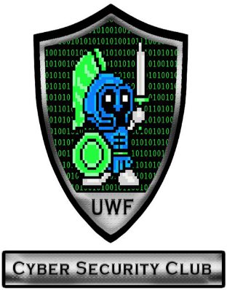***Argopulse***
      8. ***Website***
3. Surprise Pinto Talk
   1. ***Member driven***
   2. ***Non-restrictive open to all***
   3. ***Many opportunities available***